Name:
Tutor:
Course:
Date:
Basketball Camp
Last weekend I attended a basketball camp where we were meeting with the Basketball executives. I had been sent by Nike Company as the marketing representative of the organization during the camp. The place was full of players, fans among other interested parties who were eager to hear the speech which was to be delivered by the Basketball president within the US. We had a wonderful day since we listened to speeches from different key players within the Basketball game.
From the start, I knew that I had attended that basketball camp in order to enhance the image and shape the consumer attitudes towards our brands, Nike. Companies are often looking for ways through which they can improve how people or rather the community perceive them. And given that, Basketball camps were events that we could attend in order to enhance Nike's public perception, I attended in full force and prepared to enhance and reshape the consumer attitudes towards our products. Thus, on arriving, I had to set up an exhibition point whereby I could promote Nike's products. We spend the day listening to the speeches after which the people who had attended the occasion were given some time to visit the exhibition and look out for the outfits that were on display and check on the best ones.
I also engaged the different clubs that had attended the camp in order to build brand awareness. I had carried with me our products such as athletic footwear, apparel, and equipment. The following is an image showing the products that I had gone to market on behalf of the company. 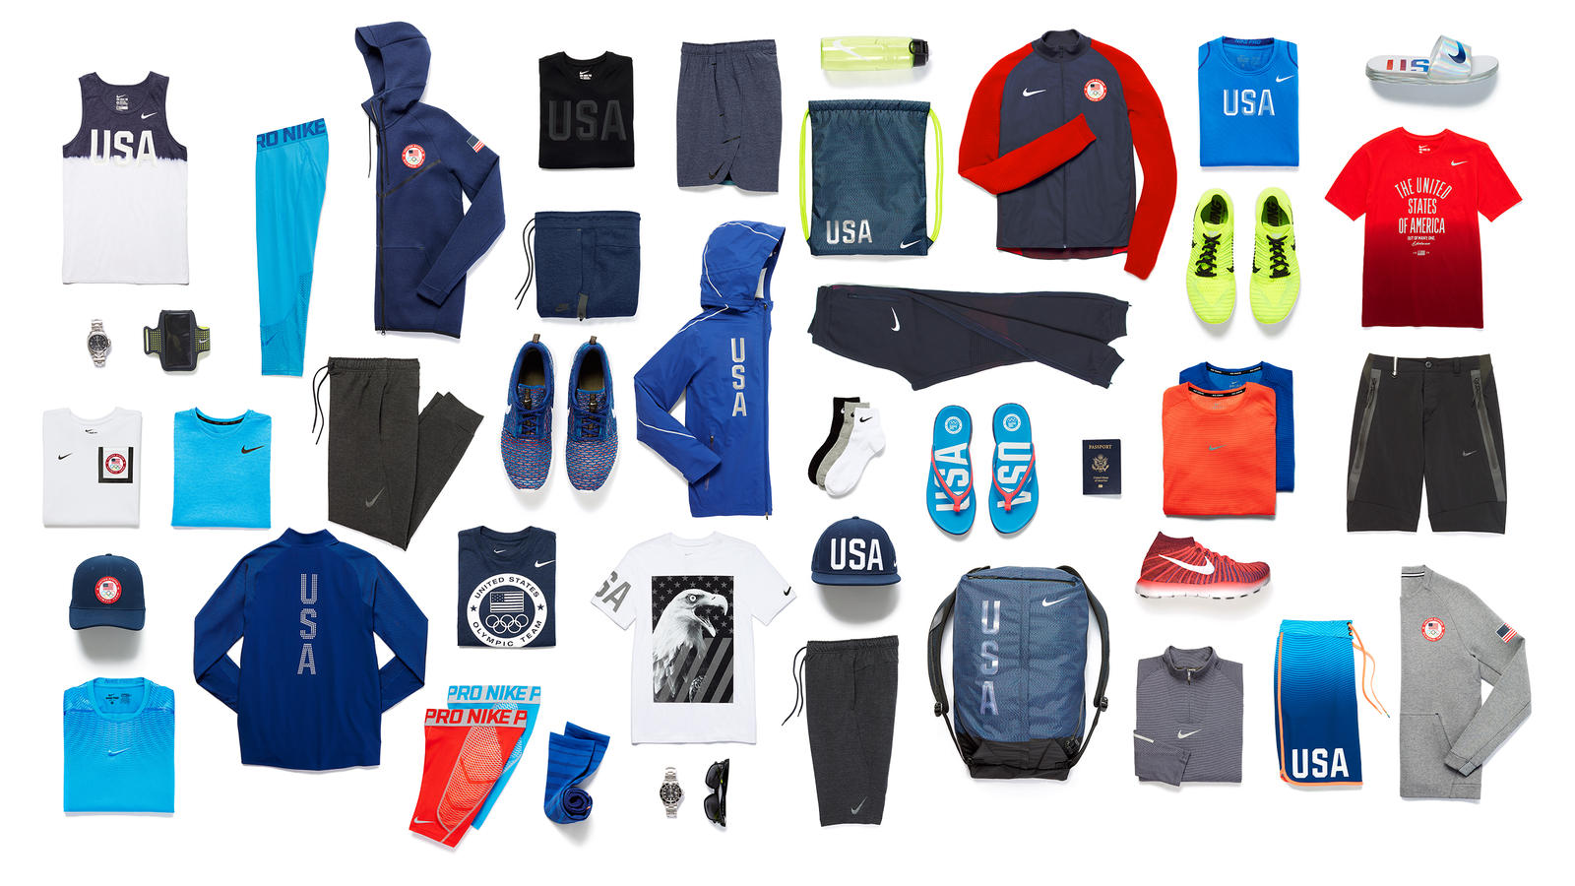

I also strived to make sure the company's presence had increased reach. During the basketball camp, I made contacts with many potential buyers and customers. I talked to people face-to-face and persuaded them to buy from the company. Also, by the end of the camp session I had already struck a deal with three teams who were going to buy all kind of wears and equipment from us. I made sure the name ‘Nike' was on all promotional material that I had carried to be camp so that I could increase awareness and also the reach of the company to the targeted potential customers. The company had also wanted to promote some kids and upcoming clubs.
The day was successful, and we ended up reaching out to the community and also individual clubs which are upcoming. Thus, we had so much to offer to the community so that it could reap the benefits at the end. The company sponsored the children who showcased their skills in playing basketball and were also promised to be taken to play with the best basketball team academies. Thus, they were assured of having their school fees being catered for by the company. The company also promised to build a field within the area so that the surrounding community could have their kids train from there. Also, the teams which took part in the camp were given uniforms among other equipment.
Through the involvement of Nike in the basketball camp, the company transformed the community in different ways. They raised hopes and dreams of some children who were needy. There were children who had no school fees among other things that are required for one to attend a school. Thus, they revived the lives of the kids who got full sponsorship since they were now assured of continuing with their education. The company also promised to create additional employment opportunities for community members. With the prevailing rate of unemployment within the states, if any company comes up with a way of creating more jobs the hopes of the community are rekindled.
From the camp I learned that such occasions are good at making one understand the organization's impact, gathering data, performing a rigorous analysis and then harnessing these insights to drive action. I was in a position to use the information that I got to demonstrate the possibility of future growth to the company's stakeholders. I also learned on what areas the company needs to improve on so that it can have a big market share; they need to customize the outfits according to the specification of a club.

